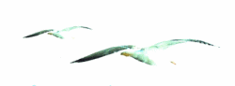
Lust Glaze Beach Hut Booking Form

Name: ……………………………………………………………

Apartment No: ………………………………………………….

Mobile: …………………………………………………………..

Dates Required: …………………………………………………

No of Persons: …………………………………………………..

Payment Method:……………………………………………….

Amount Paid:……………………………………………………

I accept the rules, terms and conditions as printed in the Lusty Glaze Details

Signed: …………………………………………………………….

Date: ……………………………………………………………….
The Beach Hut is available from 10am.
Max five persons allowed.
Safety at all times is required on the Beach.
Please complete and return with deposit to:
joydixon1@aol.com
Call:01637875127

